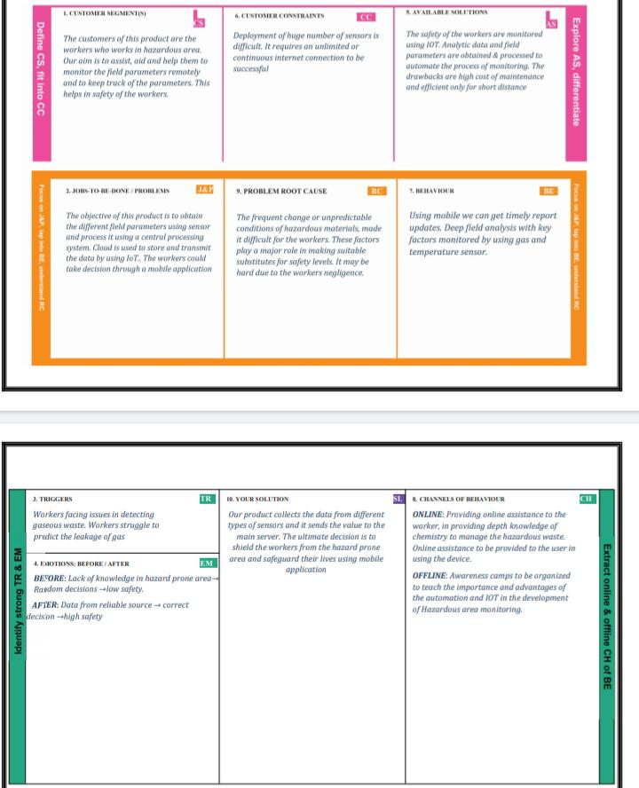Project Title: Hazardous Area Monitoring For Industrial Plants.

Project Design Phase-I- Solution Fit Template

TeamID : PNT2022TMID46546